ID.no. Press Release 2014 Business Year, 5.8.2015 PR/DG_OER, changed:
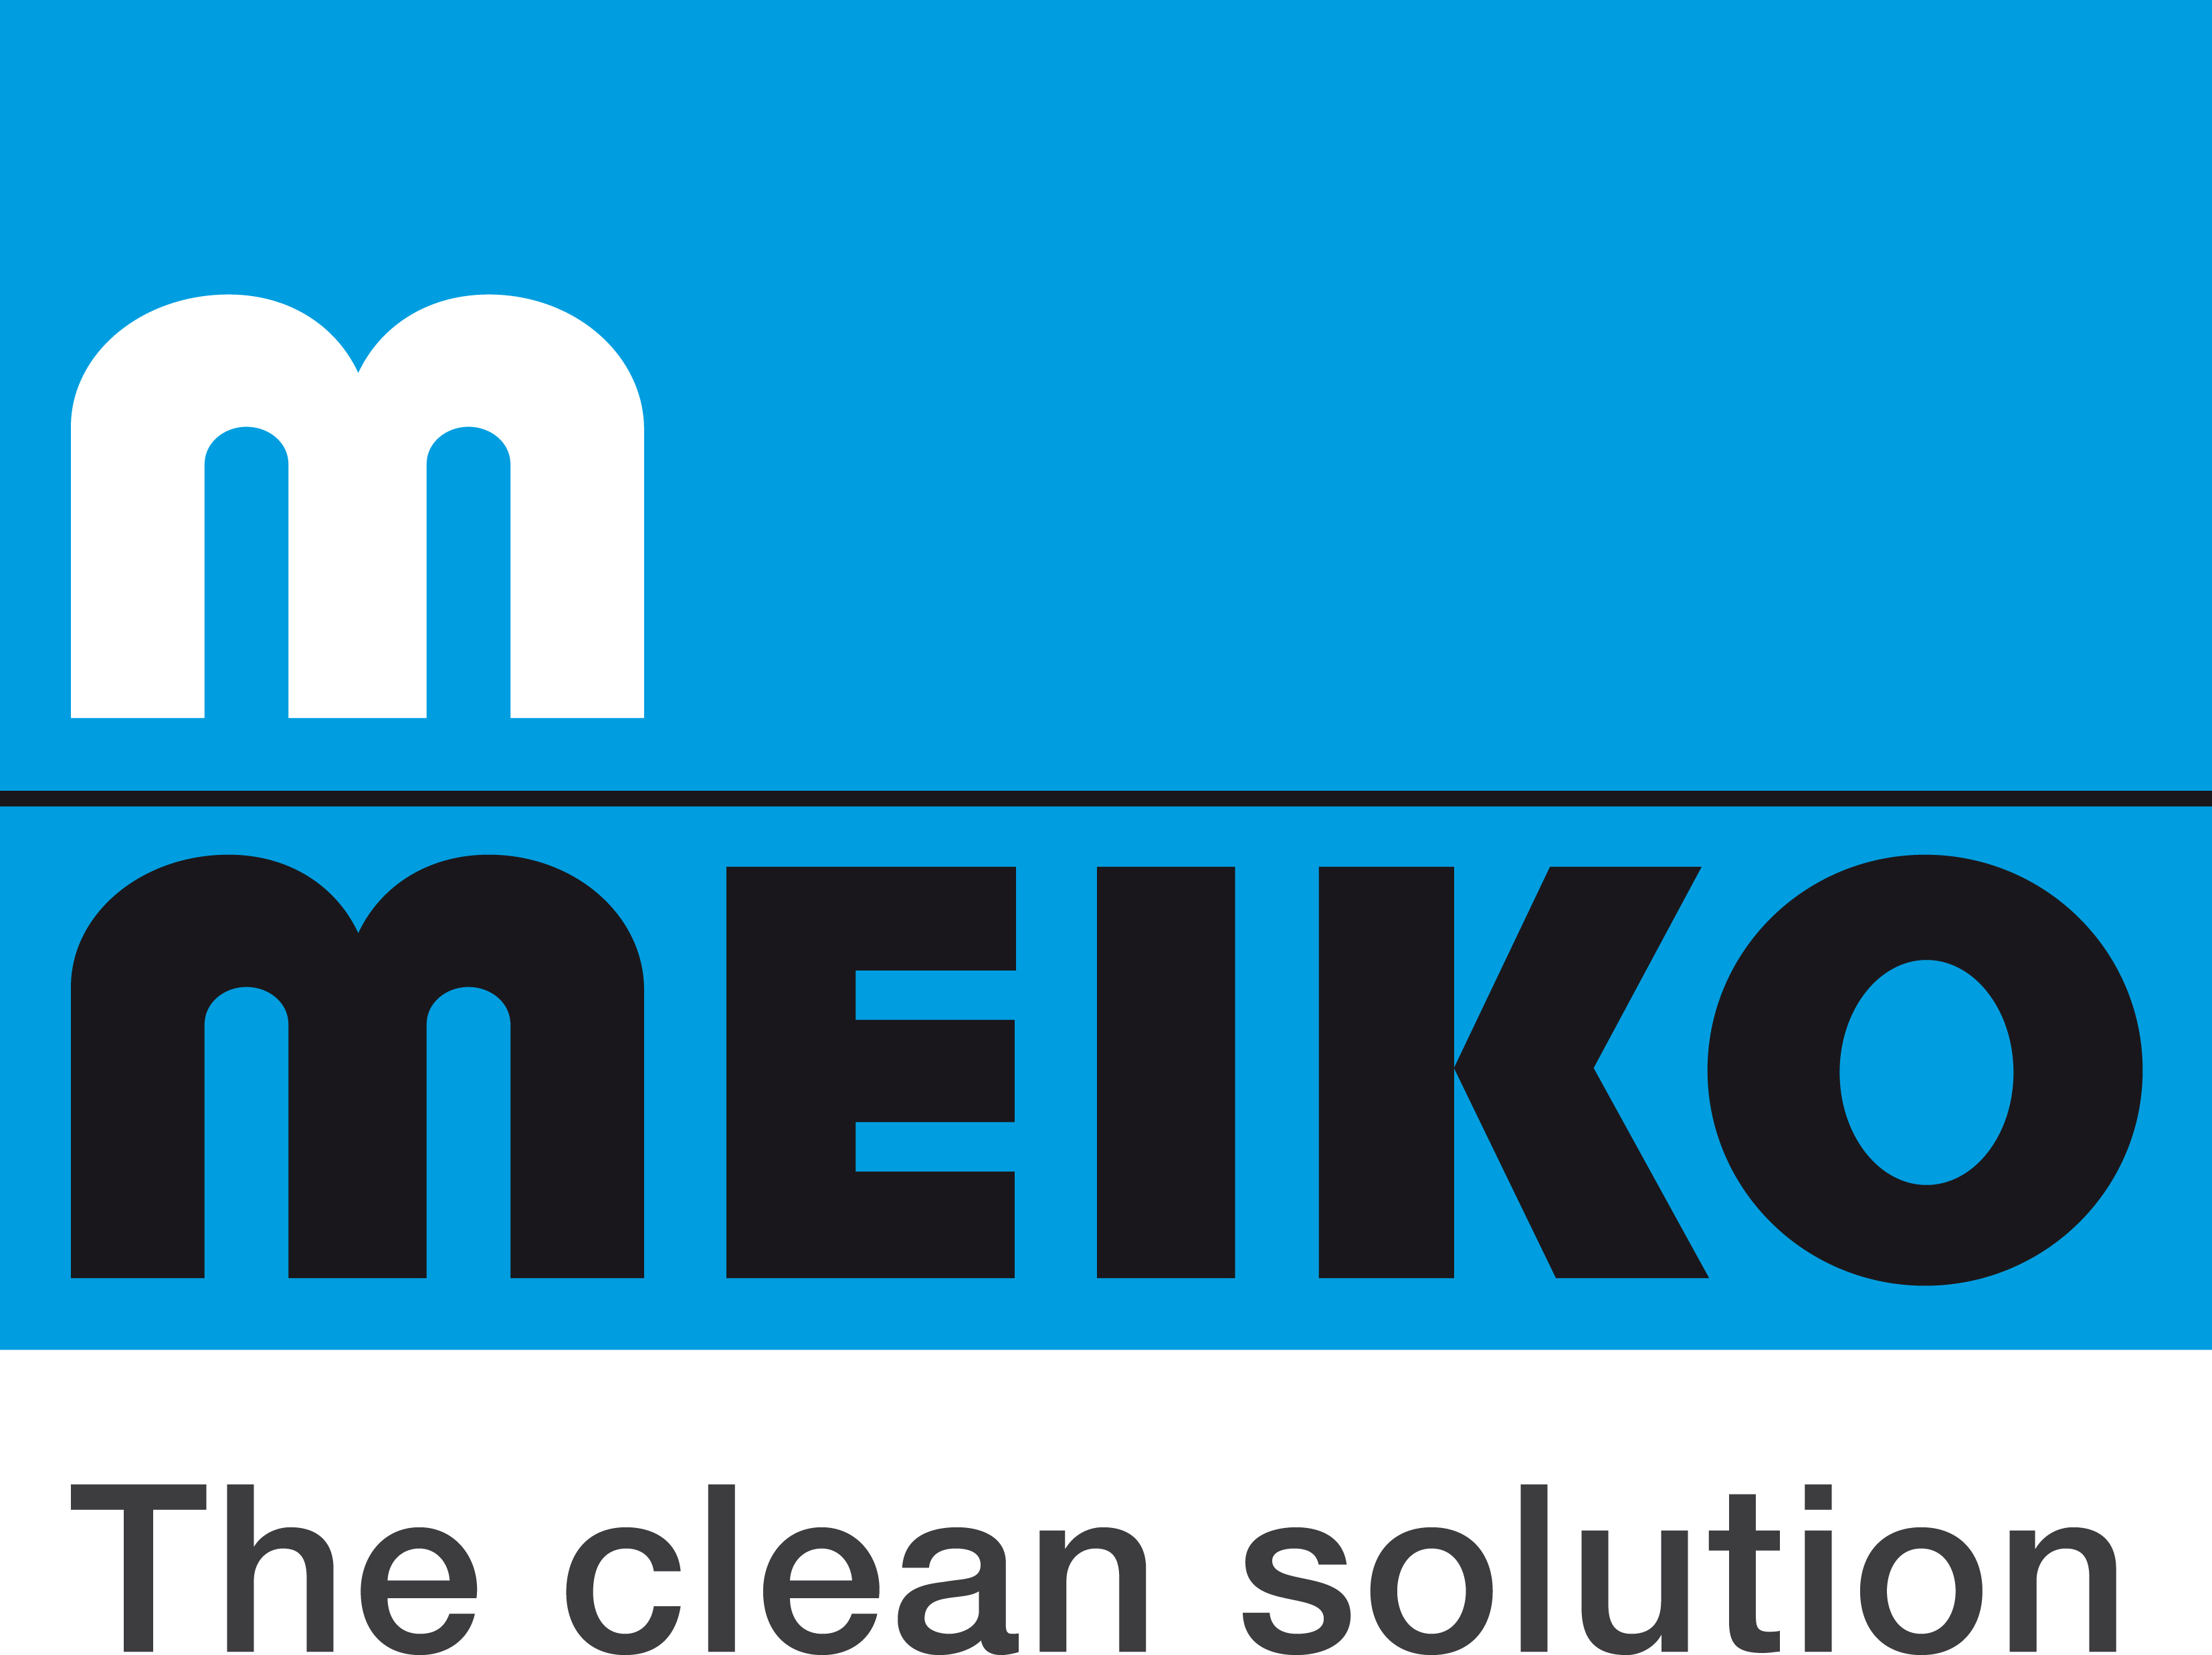
Meiko continues to grow in terms of turnover, ideas – and even better service

Meiko Maschinenbau GmbH & Co. KG clearly demonstrated its capabilities once again in 2014. The Offenburg, Germany-based specialists in commercial dishwashing technology and cleaning and disinfection technology continued the growth trend which has characterised their performance over the past few years. The Meiko Group once again increased its turnover, which rose to 274 million euros. Meiko also opened new subsidiaries in Hong Kong and Malaysia, bringing the total figure to 23: "Our products are already firmly established in emerging markets such as Indonesia, Malaysia, Singapore and Thailand. Expanding our presence in this region is the next logical step in our sales strategy," says managing director Dr.-Ing. Stefan Scheringer. The company employs more than 2,000 people worldwide, some 1,100 of whom work at its head office in Offenburg in the state of Baden-Württemberg.

With the launch of its design-oriented M-iClean range of undercounter dishwashers, Meiko has underlined its ongoing commitment to fostering innovation in the field of commercial dishwashing technology: "We'll be continuing to rejuvenate our product lines this autumn. Our experience so far has clearly shown us that saving resources should continue to be a key part of research and development at Meiko, but that our customers also appreciate product features such as intuitive user interfaces and an emphasis on dishwasher design," says Scheringer. He emphasises that Meiko is not only firmly in control of its own processes but also capable of taking a critical look at those of its customers, as demonstrated by the company's successful growth in the airline catering and marine solutions markets. "Airlines are steadily reducing the amount of time their planes stay on the ground, so the timeframe for logistics and material flow is getting shorter and shorter," Scheringer argues. "Our technology keeps pace with these developments, which is why we've been able to enter into cooperation with some of the biggest airline caterers in the world."

Growth and internationalisation are also at the forefront of Meiko's work in the field of cleaning and disinfection technology. The company recently added the 'TopClean M' to its product portfolio. This range of machines for cleaning breathing apparatus (BA) masks has rapidly evolved from an insider tip among BA equipment managers to one of the most sought-after pieces of equipment for fire services everywhere, as Scheringer explains: "Our presence at Interschutz – the world's leading exhibition for fire service and disaster relief equipment – shows we are a company that knows how to innovate. It underlines our ability to apply our 88 years of expertise and experience to meeting the challenges of industry segments we had never previously explored." Meiko technology is used to clean breathing apparatus equipment in the BA maintenance facility at Stuttgart Airport as well as at the German Armed Forces' main fire service training facility.

The machines supplied by Meiko come with a comprehensive service strategy which has proved to be invaluable to its customers. The company's innovative, all-inclusive packages of after-sales and service solutions are coordinated at the recently built Meiko World of Service facility which occupies more than 3,500 m² of space adjacent to its head office.

Meiko invested some four million euros in creating the perfect conditions for the 70 service staff who work at the facility to support the company's 23 subsidiaries, 600 service staff worldwide, and 4,500 qualified service technicians.

Meiko's ability to blend its products, service and corporate culture into a harmonious and coherent concept for its customers is reflected in the numerous awards presented to both the company and its products. Meiko has been voted as the number one manufacturer of dishwashing technology by the readers of three key trade journals – GV-Manager, First Class and 24h Gastlichkeit – and other accolades include both Gold and Silver Tophotel StarAwards, the prestigious Austrian 'Desi-Award' and, even more recently, a silver medal in the Küche Award 2015.

Infobox

Founded in 1927 by Oskar Meier and Franz Konrad
Managing director: Dr.-Ing. Stefan Scheringer
Company name: MEIKO Maschinenbau GmbH & Co. KG
Headquarters: Offenburg, Germany
Owned by: Oskar and Rosel Meier Foundation
Employees: Approx. 1,100 in Offenburg and more than 2,000 worldwide
Subsidiaries/sales companies: 24
Distribution: Meiko supplies its products to more than 90 countries
Products: Professional dishwashing technology, cleaning and disinfection technology
Customer segments: Restaurants, hotels, bars, bistros, cafés, bakeries, butchers, catering and workplace restaurants, hospitals, care homes, marine business, in-flight catering, travel catering, breathing apparatus cleaning facilities (fire services, disaster relief)

Meiko is a value-driven company – something that benefits not only its employees, but also its customers and partners.
It means that the company acts in accordance with a specific code of values. These include fairness, transparency, partnership, reliability and a sense of responsibility.
This value system is embedded within Meiko's corporate culture and nourished by a sense of continuity and by the example set by both management and staff. Its ultimate goal is to provide the best service to customers.
http://www.meiko.info/our-company/the-values-that-guide-us/

